1. Abstract
This project presents an end-to-end Variant Interpretation Pipeline designed to bridge the gap between raw genomic data and clinical decision-making. By integrating foundational sequence alignment algorithms with modern machine learning (AI) and medical databases, the system automates the transition from a genomic coordinate to disease association and therapeutic intervention. The system utilizes a relational database model to link disparate repositories including ClinVar, GWAS Catalog, and ChEMBL, providing a "Rosetta Stone" for deciphering the functional impact of genetic mutations.
2. Introduction
2.1 Background
The field of bioinformatics has evolved from the initial collection of protein sequences to massive whole-genome sequencing projects like the Human Genome Project. While the "what" of the human genome (the sequence strings) is largely identified, a "fundamental problem" remains: determining the structural and functional relationships of these sequences.
2.2 Problem Statement
Current clinical interpretation of genomic variants is often a "time-consuming, painstaking, and sometimes error-prone process". There is a significant "Interpretation Gap" where researchers must manually cross-reference data across siloed databases (GenBank, EMBL, SwissProt) to find the clinical significance of a specific mutation.
2.3 Proposed Solution
The proposed system is an automated, integrated pipeline that performs reciprocal database searches to resolve genomic coordinates into standardized Reference SNP IDs (RSIDs). It utilizes AI-driven predictors (SIFT/PolyPhen) to assess residue impact and aggregates clinical data to suggest targeted drug therapies.
2.4 Objectives
- To automate variant identification and coordinate-to-RSID resolution.
- To implement Predictive Modeling (Unit III syllabus) for classifying mutations as pathogenic or benign.
- To integrate Pharmacogenomics data from ChEMBL for therapeutic discovery.
3. System Requirements
3.1 Hardware Requirements
- Processor: High-performance CPU capable of handling exponentially growing computational steps for sequence comparisons.
- Memory: Minimum 8GB RAM (optimized for N-dimensional hypercube matrix storage).
- Graphics: WebGL-compatible GPU for 3D molecular visualization.
3.2 Software Requirements
- Operating System: Cross-platform compatibility (Windows, MacOS, UNIX).
- Interface: Web-based interface for flexibility and ease of access.
- Data Handling: API clients for real-time querying of NCBI and EBI repositories.
4. Technology Stack
- Languages: Python/Perl for backend automation scripts.
- Database: Relational Model for structured data exchange using ASN.1 formats.
- Machine Learning: Neural Networks (Hidden Markov Models) for gene and effect prediction.
- Visualization: WebGL2 for Impact Assessment modules and 3D subsystems.

5. Project Structure
- Input Module: Accepts genomic coordinates (e.g., 17:7673802:C:T) or RSIDs.
- Alignment & Mapping: Uses Global (Needleman-Wunsch) or Local (Smith-Waterman) algorithms to identify base substitutions.
- Predictive Modeling Engine: Runs AI classifiers to determine if a protein change is "Conservative" or "Moderate".
- Clinical Annotation Module: Aggregates findings from ClinVar (VCF) and GWAS (TSV).
- Drug Discovery Interface: Queries the ChEMBL database for bioactive compounds targeting specific genes (e.g., APC, TP53).

## Architecture Diagrams

### 1. System Architecture Overview

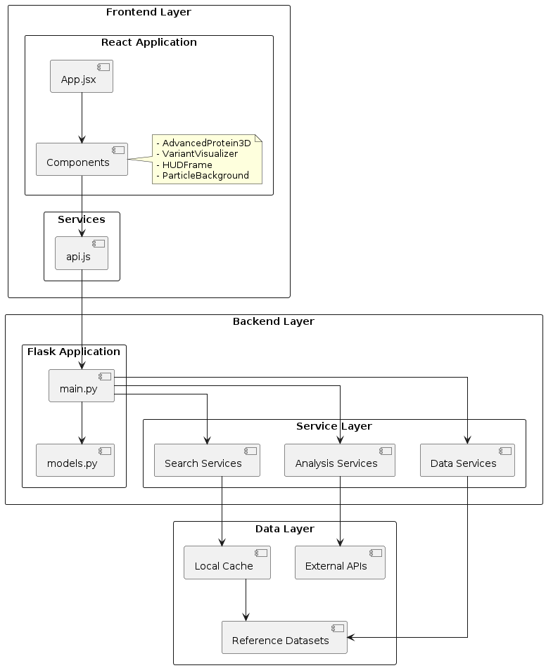

### 2. Service Layer Architecture
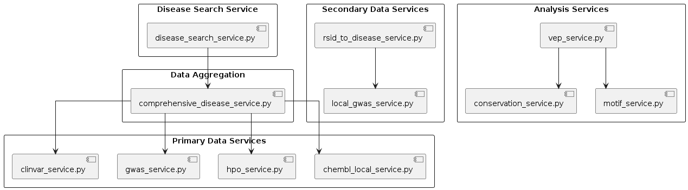

### 3. Data Flow Architecture

```plantuml
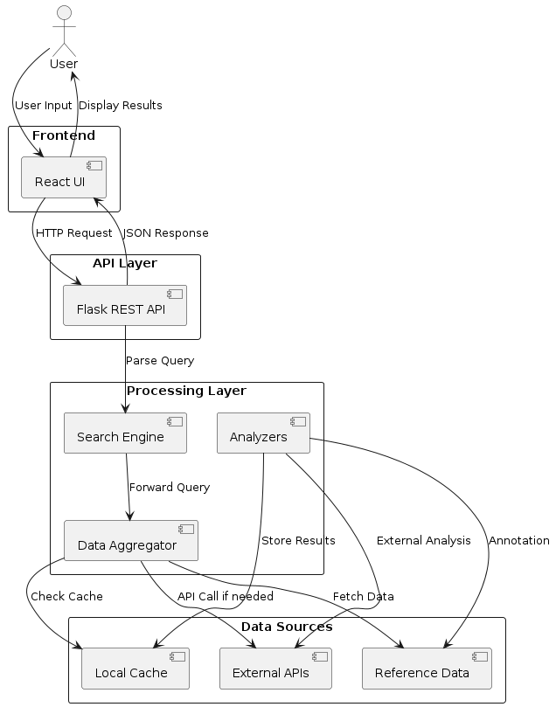

### 4. Component Interaction Diagram

```plantuml
@startuml component-interaction
!define AWSPUML https://raw.githubusercontent.com/awslabs/aws-icons-for-plantuml/v14.0/dist
skinparam linetype ortho

package "Frontend Components" {
component [App] as App
component [AdvancedProtein3D] as Protein3D
component [VariantVisualizer] as VariantViz
component [HUDFrame] as HUD
component [ParticleBackground] as Particles
}

package "API Services" {
component [API Client] as APIClient
component [Request Handler] as ReqHandler
component [Response Parser] as RespParser
}

package "Backend Services" {
component [Query Router] as Router
component [Disease Search] as DSearch
component [Result Formatter] as Formatter
}

App --> HUD
App --> Protein3D
App --> VariantViz
App --> Particles
App --> APIClient
APIClient --> ReqHandler
ReqHandler --> Router
Router --> DSearch
DSearch --> Formatter
Formatter --> RespParser
RespParser --> APIClient

@enduml

5. Database and Data Models
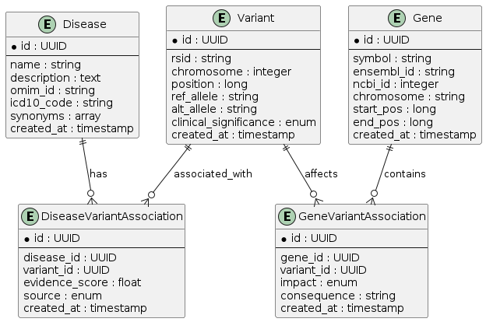

### 6. API Endpoint Architecture
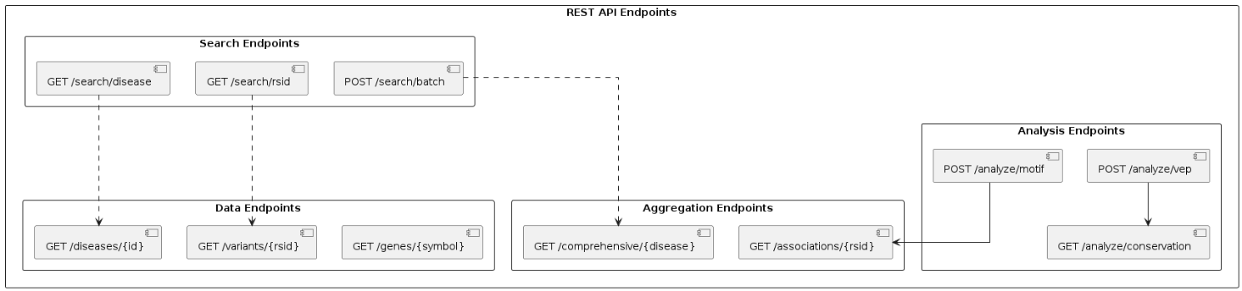

### 7. Deployment Architecture

```plantuml
@startuml deployment
!define AWSPUML https://raw.githubusercontent.com/awslabs/aws-icons-for-plantuml/v14.0/dist

rectangle "Development Environment" {
node "Local Machine" {
component [Vite Dev Server] as ViteServer
component [Flask Dev Server] as FlaskServer
}
}

rectangle "Build Process" {
component [Vite Build] as ViteBuild
component [Python Packaging] as PyPackage
}

rectangle "Production Environment" {
node "Web Server" {
component [Static Files] as StaticFiles
component [API Server] as ProdAPI
}
node "Data Storage" {
database [Datasets] as ProdData
database [Cache] as ProdCache
}
}

ViteServer --> ViteBuild
FlaskServer --> PyPackage
ViteBuild --> StaticFiles
PyPackage --> ProdAPI
ProdAPI --> ProdData
ProdAPI --> ProdCache

@enduml
```

### 8. Technology Stack
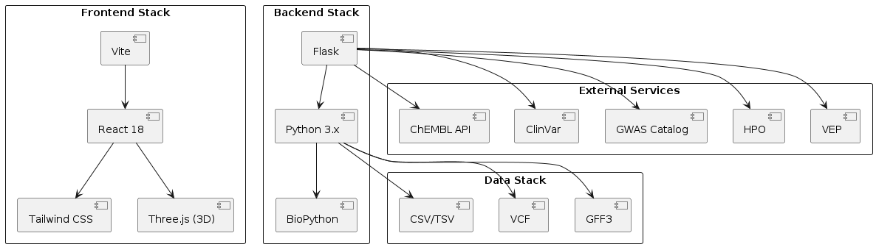

9. Request/Response Flow
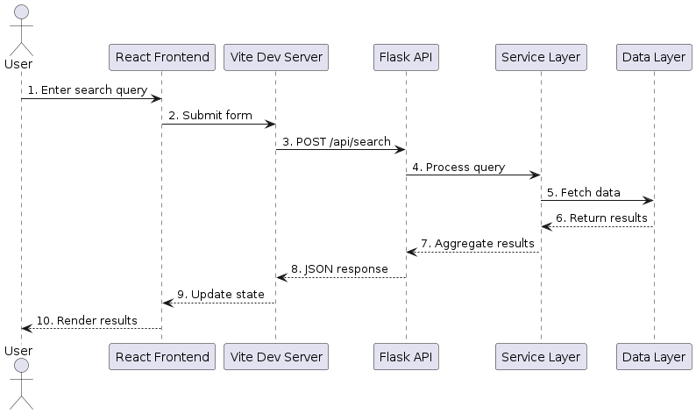

10. Error Handling Flow

```plantuml
@startuml error-handling
rectangle "Error Handling Pipeline" {
component [Request Validation] as Validation
component [Service Layer Try-Catch] as ServiceCatch
component [API Error Handler] as APIError
component [Frontend Error Display] as FrontendError
}

rectangle "Error Types" {
component [Validation Errors] as ValErrors
component [Service Errors] as SvcErrors
component [External API Errors] as ExtErrors
component [Cache Errors] as CacheErrors
}

rectangle "Error Response" {
component [Error Logger] as Logger
component [User Notification] as Notify
component [Fallback Data] as Fallback
}

Validation --> ValErrors
ServiceCatch --> SvcErrors
ServiceCatch --> ExtErrors
ServiceCatch --> CacheErrors
APIError --> Logger
Logger --> Notify
Notify --> FrontendError
SvcErrors --> Fallback

@enduml
```

6. System Architecture
The architecture follows a relational database hierarchy where sequence entries occupy rows and specific features (accession numbers, mutations, keywords) occupy columns. This allows for "neighbor" searches, where the system automatically locates similar entries across different clinical databases. The API Client acts as a daemon, interpretation, and reconstruction layer between the user and remote tools.
7. Working of the System
- Step 1: The user enters a variant coordinate into the Module Selection panel.
- Step 2: The system identifies the Base Substitution (e.g., C → T) and calculates the Polypeptide Residue Impact (e.g., Arginine → Histidine).
- Step 3: The AI engine provides a SIFT Prediction (e.g., "tolerated") based on trained neural network patterns.
- Step 4: The Disease Assoc module queries the GWAS Catalog and ClinVar to find phenotype links, such as Li-Fraumeni syndrome.
- Step 5: The Drug Discovery module identifies compounds (e.g., paclitaxel, kinase inhibitors) that target the gene in question.
8. Results and Screenshots
- Gene Variant Module: Displays the reference base vs. variant base and the resulting protein impact assessment.
- Disease Association Module: Successfully links RSIDs (e.g., rs28934576) to 6 local and API associations.
- Clinical Significance: Shows specific "Pathogenic" hits for Carcinoma and Ovarian neoplasms.
- GWAS Catalog Findings: Displays P-values (e.g., 1e-08) for traits like body fat percentage.
- Drug Discovery Interface: Successfully populates potential compounds targeting the APC gene.
9. Advantages
- Automation: Replaces manual database searching with an integrated, fast heuristic method.
- Clinical Utility: Moves from simple sequence similarity to personalized medicine and diagnostic support.
- Statistical Rigor: Ensures findings are significant through E-value and P-value assessments.
10. Conclusion
This project demonstrates that by combining the mathematical building blocks of Unit 1 (alignment, matrices) with the AI techniques of Unit 3, bioinformatics can move beyond data collection into the era of functional clinical decision support. The integration of the Drug Discovery module completes the circle of precision medicine, translating raw DNA code into therapeutic options.
11. References
- Needleman, S.B. and Wunsch, C.D. (1970). A general method applicable to the search for similarities in the amino acid sequence of two proteins. J. Mol. Biol..
- Altschul, S.F. et al. (1990). Basic local alignment search tool. J. Mol. Biol..
- Mount, D.W. (2001). Bioinformatics: Sequence and Genome Analysis. Cold Spring Harbor Laboratory Press.
- "Guidelines for releasing a variant effect predictor," Genome Biology (2025). [Teacher Reference].
- "Artificial intelligence in variant calling: a review," Frontiers in Bioinformatics (2025). [Teacher Reference].

